TITLE OF THE PAPER
(Times New Roman, size 14, bold, centered alignment)
Full Name of Presenting Authorª, Full Name of Second Author^{b}, and Full Name of Third Author^{c}…
(Times New Roman, size 11, bold, centered alignment)
ªAffiliation
^{b}Affiliation…
e-mail: presentingauthor@xx.xx
(Times New Roman, size 11, italic, centered alignment, email address of the presenting author)
Keywords: Keyword 1, Keyword 2, Keyword 3…

This template is intended for the authors of all papers submitted to the 1st Panhellenic Conference on Couple Therapy “Moving from Divergence to Synthesis” and has been designed to assist them in formatting their extended abstracts, which will be published in the Conference Proceedings.
The length of the extended paper (Final Full Paper) should range from one (1) to eight (8) complete A4 pages, using Times New Roman font, size 12.
The paper should be prepared in Microsoft Word (Windows) format. The text should have 1.5 line spacing, 2.5 cm margins on the left and right sides, and full justification alignment.
Bibliographic references should be cited within the text using sequential numbering in square brackets [1] and should be listed collectively at the end of the abstract.
Figures, images, and tables should be incorporated into the main body of the text.

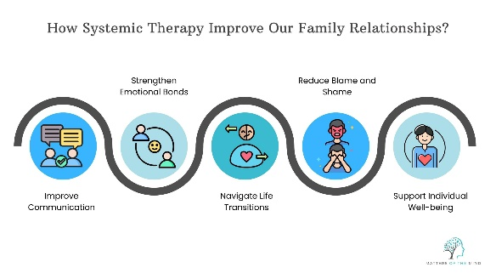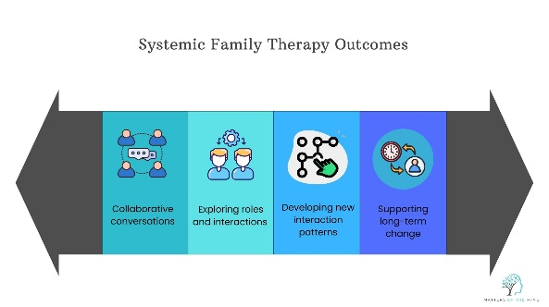

Fig. Left: How systemic therapy improve our family relationship? Right: Systemic Family Therapy Outcomes

References

[1] Author, A.A. (Year). Title of book or article. Publisher or Journal Title, volume(issue), pages.
[2] Author, A.A. & Author, B.B. (Year). Title of paper. Publisher or Journal.

