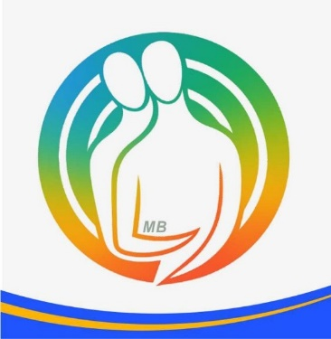
1st Panhellenic Conference on Couple Therapy
“Moving from Difference to Synthesis”
PUBLICATION CONSENT FORM FOR TEXT
Author Details
Full Name: _______________________________________
Position/Institution: _______________________________________
Title of Presentation: _______________________________________
With this document, I declare that:
- I am the author or co-author of the above-mentioned text and I have the right to grant permission for its publication.
- I consent to the publication of my text in the Conference Proceedings, as well as in any related publication concerning the conference, in printed and/or electronic format.
- I grant the conference organizers a non-exclusive and royalty-free license to reproduce, publish, distribute, and upload the text exclusively for the purposes of publishing and promoting the Conference Proceedings and the scientific outcomes of the conference.
- I declare that, to the best of my knowledge, the text does not infringe upon the intellectual property rights of third parties. In cases where third-party material is used (e.g., images, tables, or diagrams), I have obtained the necessary permissions or such use is permitted under applicable legislation.
- My personal data included in the text or in this declaration will be used by the conference organizers exclusively for the purposes of organizing the conference, publishing the proceedings, and related scientific documentation, in accordance with the applicable personal data protection legislation.
Date: ____ / ____ / ______
The Declarant
Full Name: _______________________________________
Signature: _______________________________________

